**Math 155, *Lecture Notes- Bonds* Name____________**

***Section 10.5*** *Area of a Polar Region & Arc Length in**Polar Coordinates*

The development of a formula for the area of a polar region parallels that for the area of a region on the rectangular coordinate system, but uses sectors of circles instead of rectangles as the basic element of area.

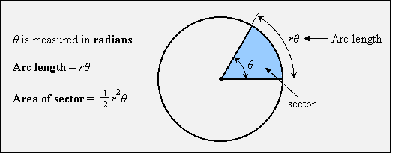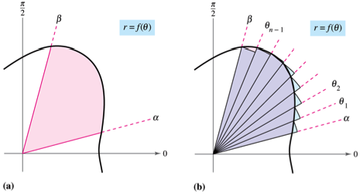

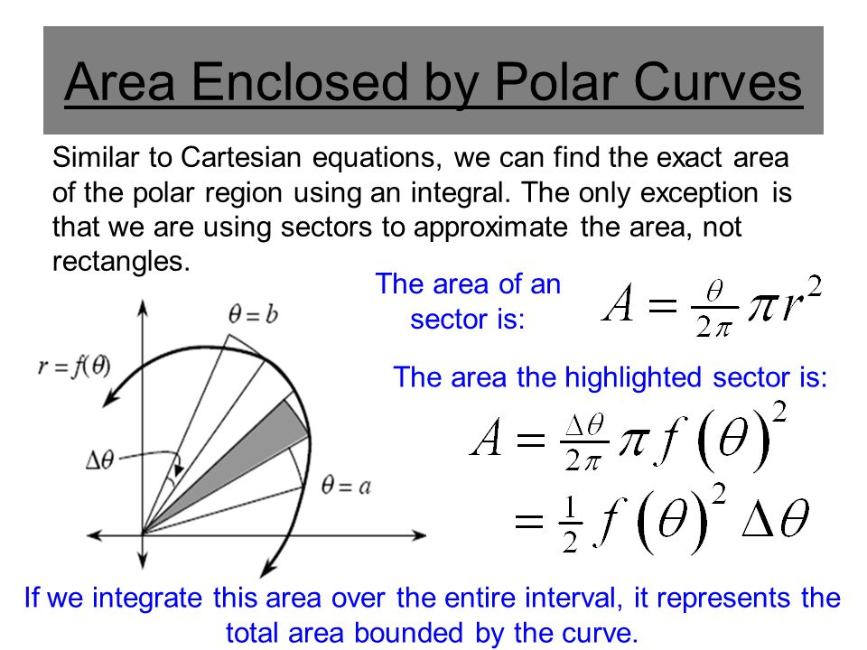

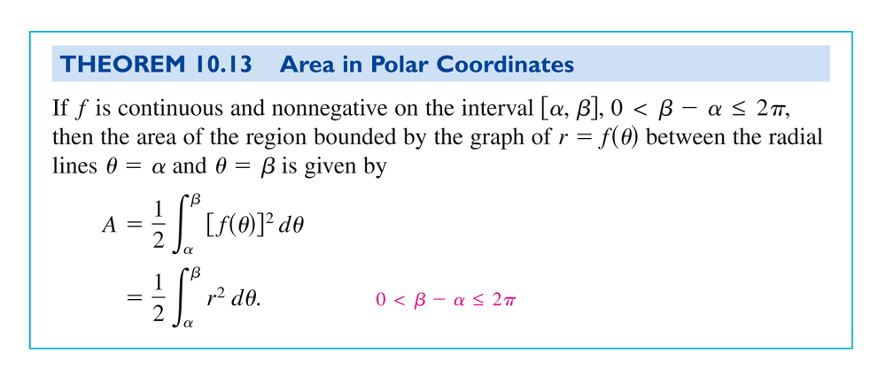

Note: The function  cannot change sign on the interval , since the sectors must be adjacent to each other as we sum their areas.

**Ex. 1:** Find the area of one petal of the curve defined by .

**More Ex. 1:**

**Ex. 2:** Find the area between the “loops” of the curve defined by .

**More Ex. 2:**

**More Ex. 2:**

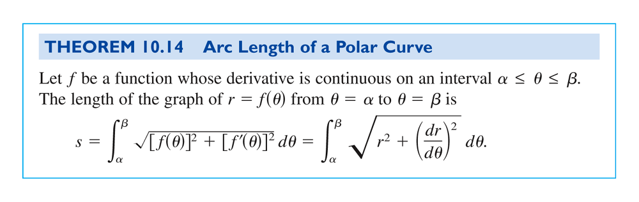

**Ex. 3:** Find the length of the curve defined by ,

over the interval .

**More Ex. 3:**